Assigning teachers or students to a category

* By default, only managers and course creators can be assigned category-wide. If you want to add teachers or students then the site administrator needs to tick the "category" box in their role in *Administration > Site administration > Users > Permissions > Define roles*.
* To ensure they will be automatically assigned as teachers/students in any new courses you make, the administrator needs to set to "allow" the capability [enrol/category:synchronised](https://docs.moodle.org/31/en/Capabilities/enrol/category:synchronised) for the role in question in *Administration > Site Administration > Users > Permissions > Define roles*.

[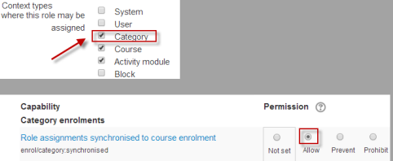](https://docs.moodle.org/31/en/File:Enrolcategorysync.png)